|  |
| --- |
| **OPT & STEM Extension**  **Location: Heritage Room of the Oakland Center**  **Time: 3:00 pm**  **Date: 10/9/2017**  We will discuss everything you need to know about post-graduation jobs, including the 24-month extension of the original 12-month OPT only for STEM Majors (Science, Technology, Engineering and Math) |
| **Employment Overview (On-Campus, CPT, & OPT)**  **Location: Heritage Room of the Oakland Center**  **Time: 3:00 pm**  **Date: 10/30/2017**  We will discuss working on-campus and off-campus during your academic career and after program completion. Representatives from Career Services will also be there to show you the benefits of visiting their office. |
| **Understanding the H-1B Work Visa Process**  **Location: Lake Michigan Room of the Oakland Center**  **Time: 3:00 pm**  **Date: 11/10/2017**  Experienced Immigration Attorney, **Alexandra Lacombe**, will answer your questions about how to apply for an H-1B Work Visa. |
| **OPT & STEM Extension**  **Location: Heritage Room of the Oakland Center**  **Time: 10:00 am**  **Date: 11/16/2017**  We will discuss everything you need to know about post-graduation jobs, including the 24-month extension of the original 12-month OPT only for STEM Majors (Science, Technology, Engineering and Math) |

|  |
| --- |
| **OPEN HOUSE – Secretary of State Processing**  **Location: Oakland/Heritage Rooms, Oakland Center**  **Time: 9:00 am – 11:30 am and 12:30 pm – 3:00 pm**  **Date: 9/12/2017**  SOS Staff & required forms will be available to begin applications for: **Michigan Driver’s License** (including written testing), or **Michigan ID Card.**  You will need an Ineligibility Letter from the Social Security Administration **before** your arrival at the Open House. |
| **Employment Overview (On-Campus, CPT, & OPT)**  **Location: Heritage Room of the Oakland Center**  **Time: 2:00 pm**  **Date: 9/25/2017**  We will discuss working on-campus and off-campus during your academic career and after program completion. Representatives from Career Services will also be there to show you the benefits of visiting their office. |
| **Understanding your Health Insurance**  **Location: Heritage Room of the Oakland Center**  **Time: 3:00 pm**  **Date: 10/5/2017**  We will discuss everything you need to know about understanding your health insurance plan. We will have representatives from the Graham Health Center to help you navigate through different medical situations. |

**Join us for a variety informational seminars!**

**Get the answers to all of your questions.**

**Details Below**

** ISSO Fall 2017 Seminar Schedule**

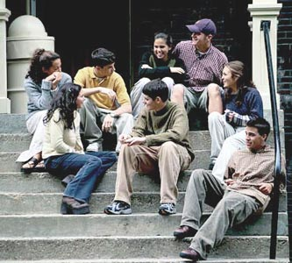

#### Next Meeting