The Department of History presents a public lecture by

Dr. Brian Porter-Szűcs
University of Michigan

Polish History and the Politics of Martyrdom

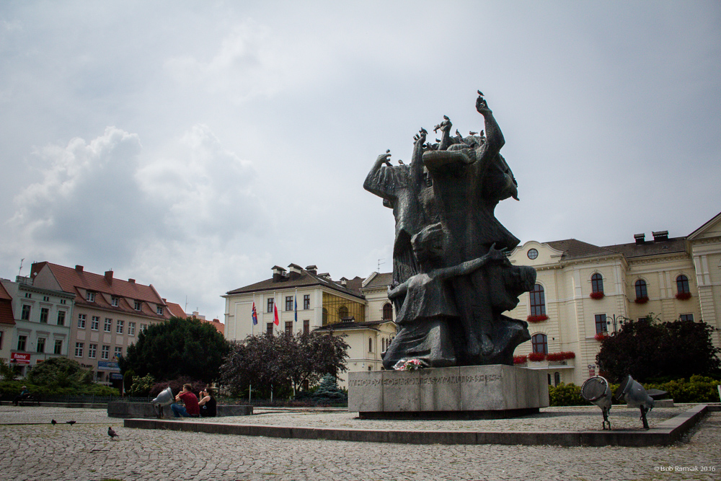

Most presentations of Poland’s past focus on the themes of sacrifice, victimization, and heroic resistance in the face of implacable evil. Such stories are not necessarily false, but they do make it hard to see the diversity, nuance, and complexity that actually characterize Polish history. Even worse, martyrologies have been deployed in recent years as political weapons,turning history into
an ideological battleground.

Tuesday, February 6, 2018 at 7:00 p.m.
Oakland Center, Banquet Room A

Brian Porter-Szűcs is Arthur F. Thurnau Professor of History at the University of Michigan and the author of numerous works on the history of Poland, nationalism, Catholicism, and antisemitism.

Open to all OU students, faculty, staff, and the general public

