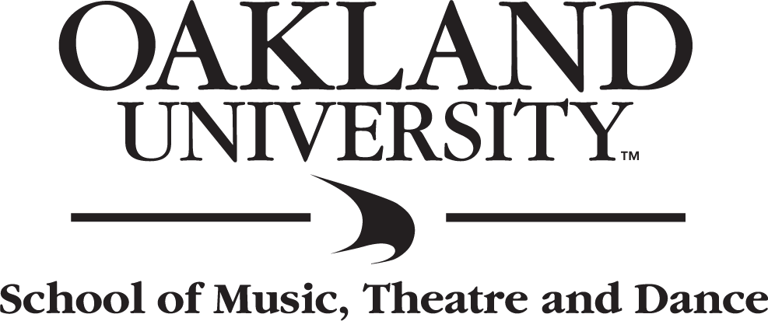

STUDENT NAME
Instrument / Voice
assisted by
Name, instrument, Name, instrument
from the studio of Professor or Dr. Full Name
- program -
Work Composer
(composer dates)
Work Composer
I. Movement with Number (composer dates)
II. Movement with Number
III. Movement with Number
IV. Movement with Number

Work Composer
(composer dates)
- intermission -
Work Composer
Movement without Number (composer dates)
Movement without Number

Work Composer
(composer dates)

Thursday, January 11, 2018
7:30 P.M.
Varner Recital Hall

This recital is presented in partial fulfillment of the requirements for the degree of
BACHELOR OF MUSIC IN MUSIC PERFORMANCE

Program Notes

Enter text here:

