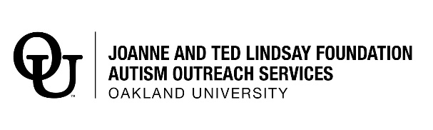
Winter 2021/2022 Pre-Employment Skills Training
SCHOLARSHIP APPLICATION FORM

OUCARES is offering limited scholarships for individuals in financial need to help pay tuition toward the
pre-employment skills training program. Completed scholarship applications will be reviewed and awarded based on recommendations from the OUCARES scholarship review committee and recipients will be notified by email.

To apply for a scholarship:
- Please submit a completed Pre-Employment Skills Training Application Form.
- Complete this Scholarship Application Form in its entirety.
- Submit Scholarship Application with proof of applicant income.
- Return to OUCARES no later than Friday, November 19, 2021

Name: | Click or tap here to enter text.
Home Address: | Click or tap here to enter text.
City | Click or tap here to enter text.
State | Click or tap here to enter text.
Zip: | Click or tap here to enter text.
Email: | Click or tap here to enter text.
Phone: | Click or tap here to enter text.
Parent/Guardian Name: | Click or tap here to enter text.
Parent/Guardian Phone: | Click or tap here to enter text.
Parent/Guardian Email: | Click or tap here to enter text.
Statement of Need: Please tell us why you are applying for this scholarship, including your primary source of income and any financial support you now receive.
Click or tap here to enter text.

In addition to this form: On a separate sheet of paper, please tell us why you want to participate in the OUCARES Pre-Employment Skills Training. Please note this must be completed by the applicant to the best of their ability.
By signing below I hereby represent:
- All information I have provided in this application is correct and true to the best of my knowledge.
- I understand there are limited scholarships available.
- My completion of this application does not guarantee a scholarship or placement in OUCARES Pre-Employment Skills Training.

Signed: Click or tap here to enter text. Date: Click or tap to enter a date.

Please return this form along with required documentations
No later than Friday, November 19, 2021 Email to:
oucares@oakland.edu

