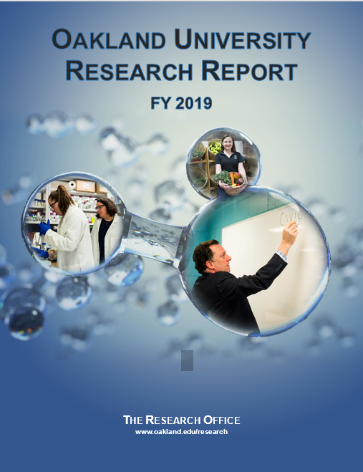

Oakland University
Research Report
Fiscal Year 2019

Cover Art
Left image: Maggie Bohr, Biomedical Science and first year medical student at OUWB
Sara Blumer-Schuette, Assistant Professor of Biological Sciences
Top right image: Jennifer Lucarelli, Associate Professor of Interdisciplinary Health Sciences
Lower right image: David Dulio, Professor of Political Science

Contents

I. Preface 3
Technical Notes and Definitions 4
II. Award Overview
Amounts and Number of Awards by Purpose................................................................................... ......6
Amounts and Number of Awards by Source ..........................................................................................8
Percentages and Award Amounts by Academic Unit............................................................ ..................9
FY 2019 Rankings.......................................................................................................................................10
Comparison of FY 2018 and FY 2019 by Unit......................................................................................10
Amount Awarded by Unit and Purpose.......................................................................................... ........13
Amount Awarded by Unit and Source …................................................................................................15
Amount Awarded by Federal Agency.............................................................................................. ........17
Amount Awarded by State/Local Agency.......................................................... ....................................18
Amount Awarded by Corporations.......................... ................................................................................18
Amount Awarded by Public/Nonprofit Sponsors........................................................ ........................19
III. Research Awards
Amounts and Number of Research Awards............................. ..............................................................20
Research Awards by Department............................... ..............................................................................21
Research Awards by Unit, Department and Principal Investigator....................................................22
IV. Instruction Awards
Amounts and Number of Instruction Awards......................................... ..............................................27
Instruction Awards by Department........................ .................................................................................28
Instruction Awards by Unit, Department and Principal Investigator.................................................29
V. Other Sponsored Activities
Amounts and Number of Other Sponsored Activities............................................ .............................30
Other Sponsored Activities by Department.............................................................. .............................31
Other Sponsored Activities Awards by Unit, Department and Principal Investigator........... .........32
VI. Proposals Submitted
Number of Proposals Submitted............................................................................................ ..................33
Percentage and Amounts Requested by Academic Unit ......................................................................35
Proposal Funding Requested by Purpose ...............................................................................................37
Proposal Funding Requested by Source ..................................................................................................39
VII. Recognition
2018 Research, Innovation and Engagement Town Hall Winners .....................................................41
PI Academy for Research and Engagement, Class of 2019. ................................................................42

Preface

The Research Office is proud to present the Fiscal Year (FY) 2019 Annual Report describing external funding at Oakland University (OU). This report gives readers a comprehensive overview of the nature and extent of external funding provided to faculty and staff to support their research, instructional, public service, and creative activities. Detailed data are also provided for proposals that were submitted in FY 2019.
During FY 2019, OU attracted just under $10 million in external funding. As experts and leaders in their fields, OU faculty and staff continue to secure external funding for a broad range of robust research programs, many of which promote strong collaborations with other universities and research institutes, private industry, and regional organizations. These collaborations are vital in a funding climate emphasizing cross-disciplinary collaboration and public-private partnerships for addressing complex societal needs.
Moreover, these sponsored programs support OU’s mission to be a student-centered public research university, providing experiential learning opportunities that position our students to become the next generation of scientists, engineers, educators, and performers, while also advancing society through the creation and mobilization of knowledge.
The Research Office deeply appreciates the efforts of the OU faculty and staff who submitted grant and contract proposals during FY 2019, and we extend our warmest congratulations to those who obtained external funding this year.

Technical Notes and Definitions

Annual Report Reporting Period
The fiscal year (FY) for OU is July 1 to June 30. This report includes data for all awards and proposals processed through the Research Office for FY 2019. An award is considered processed by the Research Office when it has been reviewed, institutionally endorsed (if necessary), and transferred to Accounting for account set up. A proposal is considered processed through the Research Office after the institutional review and sign off process is complete.

Definition of Award
An award is a funded project for which OU has received an official notice of award or executed contract from a sponsor requiring the university to undertake a particular activity and for which a deliverable is expected. Awards that provide full funding in the first year of a multi-year project are included in the fiscal year the award was made. Award dollars received from sponsors that provide funding for specific budget periods within a multi-year project (i.e. incremental awards) are included in the fiscal year for which funding is received. Consequently, funding can fluctuate for a department or college depending on how a project is funded. Direct year-by-year comparisons should always be made with caution.

Definition of Proposal
A proposal is a request for financial support for a particular sponsored activity that is routed through the Research Office. It is important to recognize that there is no correlation between the proposals and awards discussed in this report, as many of the proposals submitted for the previous year are still pending with the sponsors.

Intellectual Credit
Proposals and awards are credited to the lead principal investigator (PI) and his/her home unit or center, whether academic or otherwise. For proposals or awards that also include co-PIs, the total amount proposed or awarded is credited to the lead PI and his/her home unit. However, the participation of each co-PI named on the project is indicated with a notation under the co-PI’s home academic unit or center.

Sponsor Types
The Research Office recognizes four categories of sponsors: federal, state, corporate, and public/nonprofit. Federal sponsors for proposals and awards include direct federal funding as well as flow-through funding when federal dollars come to OU through a non-federal entity (e.g. state agency or other university). Public/nonprofit sponsors include non-Michigan institutions of higher education, municipalities, civic organizations, as well as nonprofit and non-governmental organizations.

Report Layout
This report has seven (7) sections. The first section, award overview, provides a summary of all sponsored awards received by OU through the Research Office for the previous fiscal year. The ensuing three sections include award information separated according to the following activity types: 1) research, 2) instruction, and 3) other sponsored activities. The fifth section of the report details proposal submissions for the previous fiscal year. The final sections of the report include listings of the winners of the 2018 Research, Innovation, and Engagement Town Hall and the PI Academy for Research and Engagement Class of 2019.

Research
A project is classified as research when it involves a systematic study to gain an understanding of a phenomenon. Research culminates in new knowledge and may be either fundamental or applied. A project that funds the maintenance or creation of research facilities, disseminates project findings, or trains individuals in research techniques or methods would also be classified as research.

Instruction
A project is classified as instruction when it incorporates the teaching and training activities of the institution (with the exception of research training, as mentioned above). These projects are intended to elicit some measure of educational change in learners. Instruction includes all teaching and training activities, credit or non-credit.

Other Sponsored Activities
A project is classified as “Other Sponsored Activity” when it is neither research nor instruction. These projects include public service that engages OU resources to meet local, regional, national, or international needs. Other activities include student support programs, testing and evaluation, joint appointment agreements, and some workshop or travel grants.

“Other” Academic Unit
The term “Other” is used for sponsored activities that fall outside the formal academic unit structure. This includes, but is not limited to, campus areas such as Academic Affairs Office, Athletics Administration, Campus Police, Campus Recreation, Center for Multicultural Initiatives, Facilities Management, Financial Aid, Macomb-OU Incubator, OU INC, Pre-College Programs, the Research Office, Student Affairs, and Upward Bound.

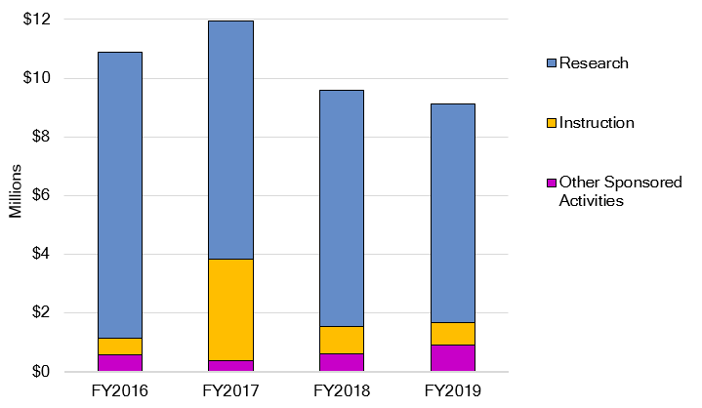
Amounts and Number of Awards by Purpose

Funding Amount of New Awards
Purpose of Funding | FY2016 | FY2017 | FY2018 | FY2019 | Total
Research | 9,732,985 | 8,126,866 | 8,074,392 | 7,465,280 | 33,399,523
Instruction | 585,612 | 3,438,237 | 910,416 | 762,032 | 5,696,297
Other Sponsored Activities | 559,440 | 379,769 | 613,804 | 894,417 | 2,447,430
Total | $10,878,037 | $11,944,872 | $9,598,612 | $9,121,729 | 41,543,250
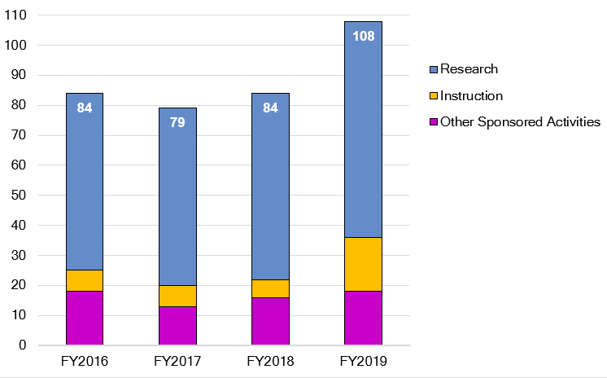

Number of Awards
Purpose of Funding | FY2016 | FY2017 | FY2018 | FY2019 | Total
Research | 59 | 59 | 62 | 72 | 252
Instruction | 7 | 7 | 6 | 18 | 38
Other Sponsored Activities | 18 | 13 | 16 | 18 | 65
Total | 84 | 79 | 84 | 108 | 355
Percentages and Number of Awards by Purpose
FY2019 ● Funding Amount Percentages

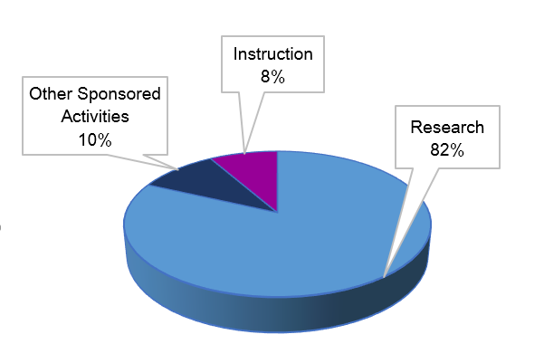

N = $9,121,729

Purpose of Funding | Number of Awards | Total
Research | 72 | 7,465,280
Instruction | 18 | 762,032
Other Sponsored Activities | 18 | 894,417
Total | 108 | $9,121,729

FY2019 ● Number of Awards - Percentage by Purpose

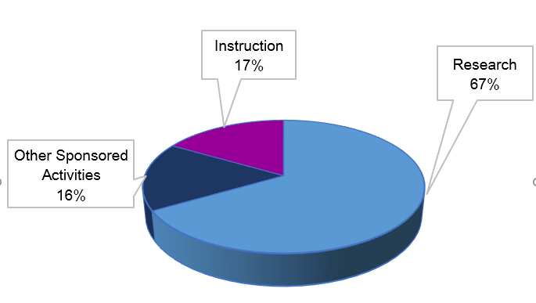

N = $9,598,612

N = 108

Percentages and Award Amounts by Source
FY2019 ● Funding Amount Percentages by Source

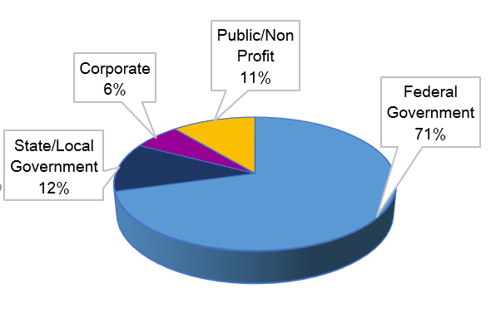

N = $9,121,729

Source of Funding | Number of Awards | Total
Federal Government | 57 | 6,451,499
State/Local Government | 22 | 1,080,201
Corporate Sponsors | 11 | 592,383
Public/Nonprofit Sponsors | 18 | 997,646
Total | 108 | $9,121,729

FY2019 ● Number of Awards by Source

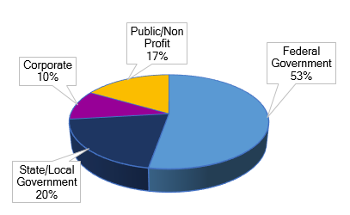

N = 108

Percentages and Award Amounts by Academic Unit
FY2019 ● Funding Amount Percentages by Academic Unit

N = $9,121,729

Academic Unit | FY2016 | FY2017 | FY2018 | FY2019 | Total
College of Arts and Sciences | 4,739,354 | 4,491,729 | 5,075,991 | 4,409,055 | 18,716,129
Eye Research Institute | 2,220,027 | 0 | 63,677 | 37,500 | 2,321,204
School of Business Administration | 0 | 0 | 16,350 | 6,420 | 22,770
School of Engineering and Computer Science | 2,536,276 | 2,813,107 | 2,604,175 | 2,741,069 | 10,694,627
School of Education and Human Services | 398,000 | 625,994 | 97,590 | 143,090 | 1,264,674
School of Health Sciences | 28,061 | 197,346 | 522,524 | 599,529 | 1,347,460
School of Medicine | 11,568 | 63,984 | 0 | 6,000 | 81,552
School of Nursing | 266,545 | 20,450 | 62,304 | 236,354 | 585,653
Other | 678,206 | 3,732,262 | 1,156,001 | 942,712 | 6,509,181
Total | $10,878,037 | $11,944,872 | $9,598,612 | $9,121,729 | 41,543,250

FY 2019 Department Rankings
 | Department/Unit | Dollars | Parent Unit
1 | Biological Sciences | 1,337,469 | College of Arts and Sciences
2 | Chemistry | 1,210,223 | College of Arts and Sciences
3 | Mechanical Engineering | 1,101,111 | College of Engineering & Computer Science
4 | Physics | 973,735 | College of Arts and Sciences
5 | Computer Science and Engineering | 907,604 | College of Engineering & Computer Science

FY 2019 Non-Academic and Other Unit Rankings
 | Department/Unit | Dollars
1 | Pre-College Programs | 212,812
2 | Macomb-OU Incubator | 197,995
3 | Research Office | 162,360
4 | Upward Bound | 113,935
5 | Graduate Study and Lifelong Learning | 104,772

Comparison of FY 2018 and FY 2019
Amounts Awarded by Academic Unit and Other Administrative Units
College of Arts and Sciences | FY2018  Awards | FY2019  Awards
Art and Art History | 0 | 10,000
Biological Sciences | 2,067,691 | 1,337,469
Chemistry | 1,163,000 | 1,210,223
Mathematics and Statistics | 0 | 108,215
Philosophy | 0 | 8,297
Physics | 1,395,296 | 973,735
Psychology | 251,788 | 651,028
Sociology, Anthropology, Social Work and Criminal Justice | 198,216 | 110,088
CAS Total | $5,075,991 | $4,409,055

Eye Research Institute | FY2018  Awards | FY2019  Awards
ERI Total | $63,677 | 37,500

School of Business Administration | FY2018  Awards | FY2019  Awards
SBA Total | $16,350 | 6,420

Comparison of FY2018 and FY2019, continued

School of Engineering and Computer Science | FY2018  Awards | FY2019  Awards
Computer Science and Engineering | 452,486 | 907,604
Electrical and Computer Engineering | 426,018 | 530,342
Industrial and Systems Engineering | 23,744 | 202,012
Mechanical Engineering | 1,701,927 | 1,101,111
SECS Total | $2,604,175 | 2,741,069

School of Education and Human Services | FY2018  Awards | FY2019  Awards
Human Development and Child Studies | 97,590 | 139,515
Organizational Leadership | 0 | 1,500
Reading and Language Arts | 0 | 2,075
SEHS Total | $97,590 | $143,090

School of Health Sciences | FY2018  Awards | FY2019  Awards
Human Movement Science | 1,000 | 221,558
Interdisciplinary Health Sciences | 521,524 | 278,909
Public and Environmental Wellness | 0 | 99,062
SHS Total | $522,524 | 599,529

School of Medicine | FY2018  Awards | FY2019  Awards
SOM Total | $0 | 6,000

School of Nursing | FY2018  Awards | FY2019  Awards
SON Total | $62,304 | 236,354

Comparison of FY2018 and FY2019, continued

Other | FY2018  Awards | FY2019  Awards
Center for Multicultural Initiatives | 645,390 | 100,483
Diversity, Equity and Inclusion | 0 | 16,355
Graduate Study and Lifelong Learning | 0 | 104,772
Library | 6,410 | 0
Macomb-OU Incubator | 145,946 | 197,995
OU Incubator | 45,950 | 34,000
Pre-College Programs | 62,680 | 212,812
Research Office | 249,625 | 162,360
Upward Bound | 0 | 113,935
Other Total | $1,156,001 | $942,712

Oakland University Total | FY2018  Awards | FY2019  Awards
Grand Total | $9,598,612 | $9,121,729

FY 2019 Amount Awarded by Unit and Purpose

College of Arts and Sciences | Research | Instruction | Other Sponsored Activities
Art and Art History | 0 | 0 | 10,000
Biological Sciences | 1,345,469 | 0 | 0
Chemistry | 1,210,223 | 0 | 0
Mathematics and Statistics | 108,215 | 0 | 0
Philosophy | 8,297 | 0 | 0
Physics | 965,735 | 0 | 0
Psychology | 651,028 | 0 | 0
Sociology and Anthropology | 0 | 0 | 110,088
CAS Total | 4,288,967 | $0 | $120,088

Eye Research Institute | Research | Instruction | Other Sponsored Activities
ERI Total | 37,500 | $0 | $0

School of Business Administration | Research | Instruction | Other Sponsored Activities
Management and Marketing | 0 | 6,420 | 0
SBA Total | 0 | $6,420 | $0

School of Engineering and Computer  Science | Research | Instruction | Other Sponsored Activities
Computer Science and Engineering | 810,554 | 97,050 | 0
Electrical and Computer Engineering | 530,342 | 0 | 0
Industrial and Systems Engineering | 202,012 | 0 | 0
Mechanical Engineering | 990,376 | 110,735 | 0
SECS Total | $2,533,284 | $207,785 | $0

School of Education and Human  Services | Research | Instruction | Other Sponsored Activities
Human Development and Child Studies | 0 | 22,168 | 117,347
Organizational Leadership | 0 | 0 | 1,500
Reading and Language Arts | 0 | 2,075 | 0
SEHS Total | $0 | $24,243 | $118,847

FY 2019 Amount Awarded by Unit and Purpose, continued

School of Health Sciences | Research | Instruction | Other Sponsored Activities
Human Movement Science | 221,558 | 0 | 0
Interdisciplinary Health Sciences | 278,909 | 0 | 0
Public and Environmental Wellness | 99,062 | 0 | 0
SHS Total | $599,529 | $0 | $0

School of Nursing | Research | Instruction | Other Sponsored Activities
SON Total | 0 | $236,354 | $0

School of Medicine | Research | Instruction | Other Sponsored Activities
SOM Total | $6,000 | $0 | $0

Other | Research | Instruction | Other Sponsored Activities
Center for Multicultural Initiatives | 0 | 100,483 | 0
Diversity, Equity and Inclusion | 0 | 0 | 16,355
Graduate Study and Lifelong Learning | 0 | 0 | 104,772
Macomb-OU Incubator | 0 | 0 | 197,995
OU Incubator | 0 | 0 | 34,000
Pre-College Programs | 0 | 72,812 | 140,000
Research Office | 0 | 0 | 162,360
Upward Bound | 0 | 113,935 | 0
Other Total | $0 | $287,230 | $655,482

Oakland University Total | Research | Instruction | Other Sponsored Activities
Grand Total | $7,465,280 | $762,032 | $894,417

FY 2019 Amount Awarded by Unit and Source
College of Arts and Sciences | Federal | State/Local | Corporate | Public/  Nonprofit
Art and Art History | 10,000 | 0 | 0 | 0
Biological Sciences | 1,255,911 | 0 | 0 | 89,558
Chemistry | 894,281 | 0 | 0 | 315,942
Mathematics and Statistics | 108,215 | 0 | 0 | 0
Philosophy | 0 | 0 | 0 | 8,297
Physics | 965,735 | 0 | 0 | 0
Psychology | 651,028 | 0 | 0 | 0
Sociology and Anthropology | 0 | 0 | 0 | 110,088
CAS Total | $3,885,170 | $0 | $0 | 523,885

Eye Research Institute | Federal | State/Local | Corporate | Public/  Nonprofit
ERI Total | $37,500 | $0 | $0 | $0

School of Business Administration | Federal | State/Local | Corporate | Public/  Nonprofit
Management and Marketing | 0 | 0 | 6,420 | 0
SBA Total | $0 | $0 | $6,420 | $0

School of Engineering and Computer Science | Federal | State/Local | Corporate | Public/  Nonprofit
Computer Science and Engineering | 867,604 | 0 | 0 | 40,000
Electrical and Computer Engineering | 316,682 | 0 | 213,660 | 0
Industrial and Systems Engineering | 152,012 | 0 | 50,000 | 0
Mechanical Engineering | 710,073 | 88,735 | 302,303 | 0
SECS Total | $2,046,371 | $88,735 | $565,963 | $40,000

School of Education and  Human Services | Federal | State/Local | Corporate | Public/  Nonprofit
Human Development and Child Studies | 0 | 139,515 | 0 | 0
Organizational Leadership | 0 | 0 | 0 | 1,500
Reading and Language Arts | 0 | 0 | 0 | 2,075
SEHS Total | $0 | $139,515 | $0 | $3,575

FY 2019 Amount Awarded by Unit and Source, continued
School of Health Sciences | Federal | State/Local | Corporate | Public/  Nonprofit
Human Movement Science | 0 | 0 | 20,000 | 201,558
Interdisciplinary Health Sciences | 49,281 | 7,000 | 0 | 222,628
Public and Environmental Wellness | 95,009 | 4,053 | 0 | 0
SHS Total | $144,290 | $11,053 | $20,000 | $424,186

School of Medicine | Federal | State/Local | Corporate | Public/  Nonprofit
SOM Total | $0 | $0 | $0 | $6,000

School of Nursing | Federal | State/Local | Corporate | Public/  Nonprofit
SON Total | $224,233 | $12,121 | $0 | $0

Other | Federal | State/Local | Corporate | Public/  Nonprofit
Center for Multicultural Initiatives | 0 | 100,483 | 0 | 0
Diversity, Equity and Inclusion | 0 | 16,355 | 0 | 0
Graduate Study and Lifelong Learning | 0 | 104,772 | 0 | 0
Macomb OU Incubator | 0 | 197,995 | 0 | 0
OU Incubator | 0 | 34,000 | 0 | 0
Pre-College Programs | 0 | 212,812 | 0 | 0
Research Office | 0 | 162,360 | 0 | 0
Upward Bound | 113,935 | 0 | 0 | 0
Other Total | $113,935 | $828,777 | $0 | $0

Oakland University Total | Federal | State/Local | Corporate | Public/  Nonprofit
Grand Total | $6,451,499 | $1,080,201 | $592,383 | $997,646

Amount Awarded by Federal Agency *
Agency/Sponsor | FY2016 | FY2017 | FY2018 | FY2019
Army Educational Outreach Program | 0 | 0 | 4,000 | 0
Centers for Disease Control and Prevention | 0 | 0 | 455,524 | 0
Environmental Protection Agency* | 0 | 0 | 90,544 | 0
Health Resources and Services Administration | 58,346 | 0 | 26,992 | 224,233
HighScope Research Foundation | 0 | 560,994 | 0 | 0
Los Alamos National Lab | 0 | 69,957 | 2,700 | 0
Michigan Council for Arts and cultural Affairs | 0 | 0 | 0 | 10,000
Michigan Department of Labor/Economic Growth | 0 | 196,023 | 0 | 0
Michigan Department of Natural Resources | 0 | 191,888 | 0 | 0
USAID | 0 | 0 | 56,844 | 0
National Advanced Mobility Consortium | 0 | 0 | 0 | 75,000
National Aeronautics and Space Administration | 628,713 | 52,500 | 41,500 | 70,000
National Center for Manufacturing Sciences | 507,772 | 105,107 | 853,372 | 0
National Endowment for the Humanities | 0 | 0 | 6,410 | 0
National Institutes of Health | 5,167,979 | 1,277,018 | 3,003,797 | 1,494,402
National Science Foundation | 1,826,724 | 3,410,486 | 979,356 | 3,289,388
National Security Agency | 119,847 | 100,000 | 200,000 | 97,050
National Writing Project | 0 | 15,000 | 0 | 0
NIDILRR-Rehabilitation Research & Training Ctrs | 0 | 55,428 | 0 | 0
Pacific Northwest National Laboratory | 0 | 82,999 | 78,085 | 0
SUNY Downstate Medical Center | 135,000 | 0 | 0 | 0
Tuskegee University | 0 | 0 | 14,994 | 0
United States Army-TACOM | 0 | 30,000 | 0 | 0
United States Army-TARDEC | 0 | 0 | 0 | 79,550
United States Army | 8,000 | 4,000 | 0 | 2,000
United States Council for Automotive Research | 0 | 80,086 | 0 | 0
United States Department of Agriculture | 59,277 | 0 | 0 | 83,281
United States Department of Defense | 0 | 0 | 749,803 | 678,039
United States Department of Education | 0 | 3,075,850 | 0 | 113,935
United States Department of Energy | 0 | 0 | 0 | 234,621
University of California | 0 | 430,000 | 0 | 0
University of Houston | 38,733 | 0 | 0 | 0
University of Iowa | 0 | 9,984 | 0 | 0
University of Michigan | 0 | 17,000 | 320,535 | 0
Veterans Affairs | 0 | 6,813 | 0 | 0
Virginia Polytechnic Institute and State University | 240,000 | 0 | 240,000 | 0
Wayne State University | 70,000 | 0 | 0 | 0
Oakland University Grand Total | $8,860,391 | $9,771,133 | $7,124,456 | $6,451,499
* Includes flow through funding
Amount Awarded by State/Local Agency

Agency/Sponsor | FY2016 | FY2017 | FY2018 | FY2019
Grand Valley State University | 290,390 | 85,000 | 0 | 84,000
Macomb County | 9,000 | 0 | 0 | 0
Macomb Intermediate School District | 0 | 0 | 65,090 | 67,347
Michigan Council for Arts and Cultural Affairs | 0 | 18,000 | 0 | 0
Michigan Department of Education | 380,000 | 0 | 0 | 22,168
Michigan Department of Environmental Quality | 0 | 158,314 | 0 | 0
Michigan Department of Health and Human Services | 0 | 88,300 | 32,500 | 50,000
Michigan Department of Labor and Economic Growth | 0 | 0 | 62,680 | 17,600
Michigan Economic Development Corporation | 25,000 | 25,000 | 442,521 | 310,355
Michigan State Police | 10,550 | 0 | 0 | 16,355
Michigan State University | 5,800 | 0 | 0 | 0
Michigan Technological University | 0 | 0 | 10,000 | 0
Oakland County Health Division | 3,761 | 5,487 | 6,000 | 7,000
Oakland County Homeland Security | 7,902 | 0 | 0 | 0
Oakland Schools | 0 | 56,800 | 0 | 0
State of Michigan | 91,364 | 91,364 | 734,125 | 505,376
Oakland University Grand Total | $ 823,767 | $528,265 | $1,352,916 | 1,080,201

Amount Awarded by Corporations
Agency/Sponsor | FY2016 | FY2017 | FY2018 | FY2019
ANIARA | 10,000 | 0 | 0 | 0
Auto/Steel Partnership | 53,072 | 0 | 0 | 0
Balance Tracking Systems | 0 | 0 | 0 | 20,000
BetaCae Systems | 0 | 63,900 | 0 | 0
Brar Technology | 5,027 | 0 | 0 | 0
Comcast Innovation Fund | 0 | 0 | 50,000 | 0
Consumers Energy | 0 | 0 | 54,000 | 0
Continental Automotive Systems, Inc. | 0 | 0 | 0 | 41,775
DTE Energy | 35,000 | 0 | 0 | 0
Dura Automotive, LLC | 0 | 0 | 0 | 132,312
Eaton Corporation | 0 | 0 | 46,000 | 0
Electric Power Research Institute, Inc. | 0 | 0 | 0 | 25,000
Fiat Chrysler Automobiles | 270,424 | 312,861 | 317,264 | 310,528
Ford Motor Company | 149,999 | 0 | 0 | 0
Hitachi America, Ltd. | 0 | 0 | 16,350 | 6,420
Hyundai Mobis Company | 0 | 0 | 60,000 | 0
I*Logic Inc | 5,000 | 0 | 0 | 0
Magna Electronics | 143,819 | 0 | 0 | 0
Molex, LLC | 0 | 0 | 0 | 56,348
PPG Industries, Inc. | 0 | 74,550 | 0 | 0
Retinal Solutions, LLC | 81,150 | 0 | 0 | 0
X-wave Innovations | 0 | 0 | 20,000 | 0
Oakland University Grand Total | $753,491 | $451,311 | $563,614 | 592,383
Amount Awarded by Public/Nonprofit Sponsors

Agency/Sponsor | FY2016 | FY2017 | FY2018 | FY2019
Academy of Applied Science | 4,000 | 0 | 0 | 0
Alliance of Coalitions for Healthy Communities | 0 | 0 | 16,500 | 0
Alpha Foundation | 0 | 0 | 175,000 | 0
American Association of Anatomists | 0 | 50,000 | 0 | 0
American Cancer Society | 0 | 20,000 | 0 | 0
American Chemical Society | 55,000 | 0 | 0 | 0
American Educational Research Association | 0 | 0 | 0 | 2,075
American Heart Association | 4,000 | 305,031 | 0 | 375,942
American Psychological Association | 0 | 1,000 | 0 | 0
American Sociological Association | 0 | 0 | 7,999 | 0
Arnold P. Gold Foundation | 4,000 | 2,000 | 0 | 0
Beaumont Research Institute | 0 | 10,143 | 0 | 0
Blue Cross Blue Shield of Michigan Foundation | 0 | 64,000 | 85,312 | 6,000
Brain Aneurysm Foundation | 0 | 0 | 0 | 40,000
Chiang Ching-Kuo Foundation | 17,500 | 0 | 0 | 0
Chicago Assoc for Research and Education in Science | 0 | 8,518 | 0 | 0
Community Foundation for Southeastern Michigan | 204,000 | 149,025 | 0 | 0
Comprehensive Early Autism Services | 0 | 32,760 | 0 | 0
DMC Foundation | 41,220 | 0 | 0 | 0
Educas AS | 0 | 0 | 23,744 | 0
Eversight | 0 | 0 | 15,000 | 0
Foundation for Food and Agriculture Research | 0 | 421,236 | 0 | 0
George Washington University | 0 | 0 | 0 | 25,119
Golf Ball Divers Alliance | 0 | 0 | 2,500 | 0
HAVEN of Oakland County | 11,600 | 0 | 0 | 0
Helping Hand for Relief and Development | 0 | 0 | 38,222 | 0
Henry Ford Health System | 0 | 0 | 59,976 | 0
Hope Warming Center | 5,014 | 0 | 0 | 0
Jonas Center for Nursing Excellence | 0 | 10,000 | 0 | 0
Judson Center, Inc. | 0 | 0 | 0 | 51,526
Lapeer County Community Foundation | 5,000 | 0 | 0 | 0
Michigan Council for Arts and Cultural Affairs | 12,000 | 0 | 0 | 0
Michigan Health Endowment Fund | 0 | 0 | 0 | 301,558
Michigan State Medical Society Foundation | 1,304 | 0 | 0 | 0
Michigan Swimmer's Itch Partnership | 0 | 0 | 0 | 29,558
National Council of Teachers of English | 0 | 10,000 | 0 | 0
National League of Nursing | 0 | 10,450 | 0 | 0
National Student Affairs in Higher Education | 0 | 0 | 0 | 1,500
Quinnipiac University | 1,250 | 0 | 0 | 0
Reading Recovery Council of North America | 18,000 | 0 | 0 | 0
Sheriff PAL/United Way | 0 | 0 | 0 | 15,000
Sociologists for Women in Society | 0 | 0 | 133,373 | 110,088
Southeast Michigan Health Association | 0 | 0 | 0 | 8,297
Stevens Institute of Technology | 8,000 | 0 | 0 | 0
The Kresge Foundation | 40,000 | 100,000 | 0 | 0
United States Soccer Federation Foundation | 8,500 | 0 | 0 | 0
University of Michigan | 0 | 0 | 0 | 30,983
Grand Total | $440,388 | $1,194,163 | $557,626 | $997,646
Amounts and Number of Research Awards

Research Awards
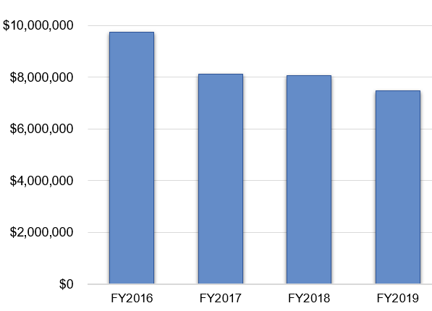
Fiscal Years 2016-2019

College/School | FY2016 | FY2017 | FY2018 | FY2019
College of Arts and Sciences | 4,727,354 | 4,425,969 | 4,942,618 | 4,288,967
Eye Research Institute | 2,220,027 | 0 | 63,677 | 37,500
School of Business Administration | 0 | 0 | 16,350 | 0
School of Engineering and Computer Science | 2,528,276 | 2,813,107 | 2,493,911 | 2,533,284
School of Education and Human Services | 18,000 | 625,994 | 0 | 0
School of Health Sciences | 19,561 | 197,346 | 522,524 | 599,529
School of Medicine | 11,568 | 54,000 | 0 | 6,000
School of Nursing | 208,199 | 10,450 | 35,312 | 0
Total | $9,732,985 | $8,126,866 | $8,074,392 | $7,465,280
Purpose of Funding: Research

FY 2019 Research Awards by Source
Source | Amount | Amount Percentage | Number of Awards | Number Percentage
Federal | 5,984,281 | 80.1% | 46 | 63.9%
State/Local | 11,053 | 0.2% | 2 | 2.8%
Corporate | 585,963 | 7.9% | 10 | 13.9%
Public/Nonprofit | 883,983 | 11.8% | 14 | 19.4%
Total | $7,465,280 | 100.0% | 72 | 100.0%
Research Awards by Department
Fiscal Years 2016 – 2019
College of Arts and Sciences | FY2016 | FY2017 | FY2018 | FY2019
Biological Sciences | 729,490 | 2,578,789 | 2,067,691 | 1,345,469
Chemistry | 1,130,098 | 313,845 | 1,163,000 | 1,210,223
Mathematics and Statistics | 19,847 | 0 | 0 | 108,215
Modern Languages and Literatures | 17,500 | 0 | 0 | 0
Philosophy | 0 | 0 | 0 | 8,297
Physics | 2,818,819 | 675,829 | 1,395,296 | 965,735
Psychology | 11,600 | 797,506 | 251,788 | 651,028
Sociology and Anthropology | 0 | 50,000 | 64,843 | 0
Writing and Rhetoric | 0 | 10,000 | 0 | 0
CAS Total | $4,727,354 | $4,425,969 | $4,942,618 | 4,288,967

Eye Research Institute | FY2016 | FY2017 | FY2018 | FY2019
ERI Total | $2,220,027 | $0 | $63,677 | $37,500

School of Business Administration | FY2016 | FY2017 | FY2018 | FY2019
Decision and Information Sciences | 0 | 0 | 0 | 0
Management and Marketing | 0 | 0 | 16,350 | 0
SBA Total | $0 | $0 | $16,350 | $0

School of Engineering and Computer Science | FY2016 | FY2017 | FY2018 | FY2019
Computer Science and Engineering | 746,526 | 1,183,780 | 342,222 | 810,554
Electrical and Computer Engineering | 117,477 | 999,299 | 426,018 | 530,342
Industrial and Systems Engineering | 35,000 | 55,000 | 23,744 | 202,012
Mechanical Engineering | 1,629,273 | 575,028 | 1,701,927 | 990,376
SECS Total | $2,528,276 | $2,813,107 | $2,493,911 | $2,533,284

School of Education and Human Services | FY2016 | FY2017 | FY2018 | FY2019
Educational Leadership | 0 | 0 | 0 | 0
Human Development and Child Studies | 0 | 625,994 | 0 | 0
Reading and Language Arts | 18,000 | 0 | 0 | 0
SEHS Total | $18,000 | $625,994 | $0 | $0

Research Awards by Department, continued
Fiscal Years 2016 – 2019
School of Health Sciences | FY2016 | FY2017 | FY2018 | FY2019
Human Movement Science | 0 | 23,300 | 1,000 | 221,558
Interdisciplinary Health Sciences | 19,561 | 174,046 | 521,524 | 278,909
Public and Environmental Wellness | 0 | 0 | 0 | 99,062
SHS Total | $19,561 | $197,346 | $522,524 | $599,529

School of Medicine | FY2016 | FY2017 | FY2018 | FY2019
SOM Total | $11,568 | $54,000 | $0 | $6,000

School of Nursing | FY2016 | FY2017 | FY2018 | FY2019
SON Total | $208,199 | $10,450 | $35,312 | $0

Oakland University Total | FY2016 | FY2017 | FY2018 | FY2019
Grand Total Research | $9,732,985 | $8,126,866 | $8,074,392 | $7,465,280
Grand Total Funding | $10,878,037 | $11,944,872 | $9,598,612 | $9,121,729

FY 2019 Research Awards by Unit, Department, and Principal Investigator
College of Arts and Sciences
Biological Sciences
Govind, Chhabi; Role of Histone Chaperones in Transcription and Chromatin Structure; National Institutes of Health, $443,592
Hansen, Fay; Evaluating Antibiotic Resistance in Locally Grown Fresh Produce with the Aim to Enhance Urban Food Sustainability; USDA, $83,281
Lal, Shailesh; Genetic, Molecular, and Biochemical Dissection of RNA Splicing Factors Critical for Maize Endosperm Development; National Science Foundation, $97,722
Liu, Zijuan; Role of ZIP8 in Regulation of Liver Methionine Metabolism; National Institutes of Health, $150,000
Raffel, Thomas; Exploring Swimmer's Itch Drivers with a State-Wide Snail Survey and Mesocosm Experiments; Michigan Swimmer's Itch Partnership, $29,558
Song, Mi Hye; Centrosome Regulation and Its Link to the Cell Cycle; National Institutes of Health, $442,500
Villa-Diaz, Luis; Use of Simulated Microgravity to Investigate Stem Cell Properties; Michigan Space Grant Consortium, University of Michigan, $5,000
Villa-Diaz, Luis; Low-Cost Methods for Simulated Microgravity and Characterization of Integrin-Alpha6 in Space; Michigan Space Grant Consortium, University of Michigan, $3,000
Westrick, Randal; AHA Summer Undergraduate Fellowship Program; American Heart Association, $60,000
Westrick, Randal; Characterization of an Isoform Specific Anticoagulant Function of TFPI-alpha; National Institutes of Health, $30,816
Chemistry
Avery, Adam; Drug Discovery for Spinocerebellar Ataxia, Using Novel Fluorescence Technology Targeting Beta-III-Spectrin; National Institutes of Health, $294,985
Dembinski, Roman; MRI: Acquisition of an EPR X-Band Spectrometer; National Science Foundation, $289,760
Martic, Sanela; Amyloid Disease of the Heart: Mechanism and Treatment; American Heart Association, $161,942
Szlag, David; Detection of Microcystins with Aptamer Based Biolayer Interferometry; Michigan Space Grant Consortium, University of Michigan, $5,000
Wu, Colin; Evaluation of Cardiovascular Risk of BRCA1 Mutation Carriers; American Heart Association, $154,000
Wu, Colin; Evaluating the Delayed Effects of Microgravity on Human Health; Michigan Space Grant Consortium, University of Michigan, $5,000
Yang, Ziming; Investigating Mineral-Promoted Amino Acid Interconversions in Hydrothermal Fluids; Michigan Space Grant Consortium, University of Michigan, $5,000
Zeng, Xiangqun; EAGER SitS: Multimodal Gas Sensor for In Situ Methane and Carbon Dioxide Detection in Arctic Soils; National Science Foundation, $294,536
Mathematics and Statistics
Tran, Nghia; Second-Order Variational Analysis in Structured Optimization Problems and Algorithms; National Science Foundation, $108,215
Philosophy
Navin, Mark; Vaccine Mandates and Co-Opted Governance in Southeast Michigan; Southeast Michigan Health Association, $8,297
Physics
Cholis, Ilias; Modeling Solar Modulation of Cosmic Rays Analytically with Data from 2006 to 2016; Michigan Space Grant Consortium, University of Michigan, $5,000
Srinivasan, Gopalan; Hexagonal Ferrite-Ferroelectric Core-Shell Nanofibers, Field-Assisted Assembly of Superstructures; National Science Foundation, $448,736
Srinivasan, Gopalan; Non-Linear Magneto-Electric Interactions in Thin Films of Hexagonal Ferrites and Voltage-Tunable High Frequency Ferrite Devices; National Science Foundation, $400,000
Zhang, Wei; Microwave Excitation of Nitrogen-Vacancy Centers in Diamond; Department of Energy / Argonne National Laboratory, $39,999
Zhang, Wei; THZ Spintronics with Antiferromagnetic Heterostructures; United States Air Force, $66,000
Zhang, Wei; Investigating Modulated Laser Pumping and Heating for Spin-Based Energy Harvesting; Michigan Space Grant Consortium, University of Michigan, $3,000
Zhang, Wei; Investigating Layer Stacking Effect and the Lateral and Vertical Temperature Profiles; Michigan Space Grant Consortium, University of Michigan, $3,000
Psychology
Escobar, Martha; An HBCU Alliance - A Model to Promote URM Junior Faculty Advancement in the STEM Professoriate; National Science Foundation, $458,797
Escobar, Martha; Collaborative Research: Strategies: Black Girls from Alabama for Computing (LeGACY); National Science Foundation, $192,231
Eye Research Institute
Zhang, Dao-Qi; Functional Organization of the Dopaminergic Network; National Institutes of Health, $37,500
School of Engineering and Computer Science
Computer Science and Engineering
Chen, Jingshu; A User-friendly Fault Injection Framework for Reliable Autonomous System Development; Michigan Space Grant, $3,000
Fu, Huirong; REU Site: Undergraduate Computer Research (UnCore) in Cyber Security; National Science Foundation, $360,000
Fu, Huirong; REU Site: Undergraduate Computer Research (UnCore) in Cyber Security, National Science Foundation, $20,000
Malik, Khalid Mahmood; Forensic Examiner: Testbed for Benchmarking Digital Audio Forensic Algorithms; National Science Foundation, $199,909
Malik, Khalid Mahmood; Forensic Examiner: Testbed for Benchmarking Digital Audio Forensic Algorithms; National Science Foundation, $8,000
Malik, Khalid Mahmood; NeuroAssist: An Intelligent Decision Support System for Prediction of Brain Aneurysm Rupture; Brain Aneurysm Foundation, $40,000
Rrushi, Julian; Defense OS-Resident Cyber Deception Operations Rooted in MILDEC; United States Air Force, $179,645
Electrical and Computer Engineering
Cheok, Ka C.; Robotics Technology Kernel (RTK) for Logistics Automation Autonomous Driving; Great Lakes Systems and Technology LLC/National Advanced Mobility Consortium, $75,000
Li, Jia; Dynamic Date Driven Multistatic EO/RF Sensor Fusion; Air Force Office of Scientific Research, $207,504
Louie, Wing-Yue; Driver State Monitoring System; Dura Automotive, LLC, $64,171
Louie, Wing-Yue; Evaluating a Virtual Reality-based Interface for Teaching Humanoids; Michigan Space Grant Consortium, $5,000
Qu, Hongwei; Material Characterization for Electroplated Contacts; Molex, LLC, $56,348
Rawashdeh, Osamah; Dura Automotive Driver State Monitoring; Dura Automotive, $68,141
Rawashdeh, Osamah; Propulsion System Optimization for a Gas-Electric Hybrid Drone; Michigan Space Grant Consortium, $3,000
Tang, Jing; Toward Next Generation Positron Emission Tomography/Magnetic Resonance Imaging; National Science Foundation, $26,178
Zohdy, Mohamed; Support for Artificial Intelligence Algorithm for Air Quality Control; Electric Power Research Institute, Inc., $25,000
Industrial and Systems Engineering
Nezammoddini, Nasim; Designing Self-Adaptive Algorithms for Cognitive Spacecraft; Michigan Space Grant Consortium, $5,000
Pandey, Vijitashwa; Alignment Repair Strategies to Reduce Warranty Costs using a Probabilistic Decision Model; Fiat Chrysler Automobiles, $50,000
Pandey, Vijitashwa; A Decision-Based Mobility Model for Semi and Fully Autonomous Vehicles; United States Army TARDEC, $79,550
Pandey, Vijitashwa; A Decision-Based Mobility Model for Semi and Fully Autonomous Vehicles; United States Army TARDEC, $67,462
Mechanical Engineering
Barber, Gary; Mechanical Properties of 52100 Steel; Fiat Chrysler Automobiles, $40,000
Golovashchenko, Sergey; CLIC Form; Fiat Chrysler Automobiles, $110,264
Golovashchenko, Sergey; CLIC Form; Fiat Chrysler Automobiles, $110,264
Guessous, Laila; Numerical Analysis and Evaluation of Common Thermal Dissipation Strategies for Electronics Cooling; Continental Automotive Systems, Inc., $41,775
Guessous, Laila; REU Site: Automotive and Energy Research and Industrial Mentorship (AERIM) Program at Oakland University; National Science Foundation, $370,304
Shall, James; Adhesion Mechanics of Van der Waals Interfaces: Fundamental Nanoscale Experiments and Simulations; Air Force Office of Scientific Research, $108,147
Nassar, Sayed/Yang, Lian; Planning IUCRC Oakland University: Center for Digital Composite Joining and Repair; National Science Foundation, $15,000
Zhao, Peng; MISR: miniature Ignition Screening Rapid Compression Machine for Kinetic Measurements of Novel Fuel; United States Department of Energy, $194,622
School of Health Sciences
Human Movement Science
Arena, Sara; Direct Community Referrals to the HOP-UP-PT; Michigan Health Endowment Fund, $201,558
Goble, Daniel; Normative Data for the Balance Tracking System; Balance Tracking Systems, $20,000
Interdisciplinary Health Sciences
Lucarelli, Jennifer; PAL Needs Assessment and Evaluation; Sheriff PAL/United Way, $15,000
Lucarelli, Jennifer; PAL Prescription for Healthy Families; Michigan Health Endowment Fund, $100,000
Papadimitriou, Christina; No One Listens to Me - Understanding Recovery When Patients Cannot Speak for Themselves; George Washington University, $25,119
Rohn, Edward; Phenomenology of Chronic Pain after Spinal Cord Injury: Experience, Adaptation and Qualify of Life; United States Army, $49,281
Rohn, Edward; Phenomenology of Chronic Pain after Spinal Cord Injury: Experience, Adaptation and Qualify of Life; United States Army, $30,983
Stevenson, Laurel; Judson Center Evaluation; Judson Center, Inc., $51,526
Stevenson, Laurel; Wellness Evaluation Project – NPC; Oakland County Health Department, $7,000
Public and Environmental Wellness
Dallo, Florence; Stress (Early Childhood and Politically-Related) and Health; Harvard University, $64,609
Dallo, Florence; Michigan Center for Contextual Factors in Alzheimer's Disease; National Institutes of Health, $30,400
Olawoyin, Richard; State of Michigan Independent Risk Analysis for the Straits Pipeline; State of Michigan, $4,053
School of Medicine
Baker, Erin; Retrospective Review of Infected Shoulder Arthroplasty Cases to Assess Infections; Blue Cross Blue Shield of Michigan Foundation, $3,000
Wasserman, Jason; Street Medicine Pontiac: A Collaboration and Extension of the Gary Burnstein Community Health Clinic and the Oakland University William Beaumont Student Run Free Clinic; Blue Cross Blue Shield of Michigan Foundation, $3,000

Instruction Awards
Instruction Awards
Fiscal Years 2016-2019
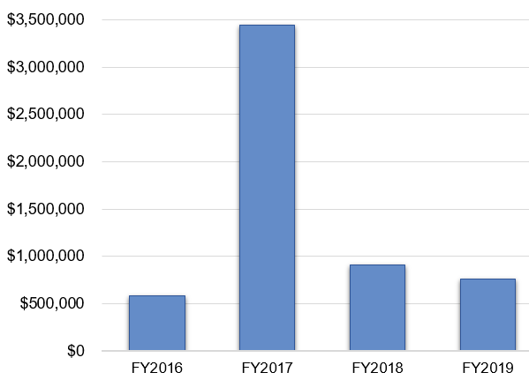

Academic Unit Comparison
Academic Unit | FY2016 | FY2017 | FY2018 | FY2019
College of Arts and Sciences | 0 | 15,000 | 0 | 0
School of Business Administration | 0 | 0 | 0 | 6,420
School of Engineering and Computer Science | 0 | 0 | 110,264 | 207,785
School of Education and Human Services | 8,000 | 0 | 65,090 | 24,243
School of Medicine | 380,000 | 10,000 | 0 | 0
School of Nursing | 58,346 | 0 | 26,992 | 236,354
Other | 139,266 | 3,413,237 | 708,070 | 287,230
Total | $585,612 | $3,438,237 | $910,416 | $762,032

FY 2019 Instruction Awards by Source
Source | Amount | Amount Percentage | Number of Awards | Number Percentage
Federal | 457,218 | 60.0% | 10 | 55.5%
State/Local | 296,319 | 38.9% | 6 | 33.3%
Corporate | 6,420 | 0.8% | 1 | 5.6%
Public/Nonprofit | 2,075 | 0.3% | 1 | 5.6%
Total | $762,032 | 100.0% | 18 | 100.0%

Instruction Awards by Department
Fiscal Years 2016 – 2019
College of Arts and Sciences | FY2016 | FY2017 | FY2018 | FY2019
Writing and Rhetoric | 0 | 15,000 | 0 | 0
CAS Total | $0 | $15,000 | $0 | $0

School of Business Administration | FY2016 | FY2017 | FY2018 | FY2019
Writing and Rhetoric | 0 | 0 | 0 | 6,420
CAS Total | $0 | $0 | $0 | $6,420

School of Engineering and Computer Science | FY2016 | FY2017 | FY2018 | FY2019
Computer Science and Engineering | 8,000 | 0 | 0 | 97,050
Mechanical Engineering | 0 | 0 | 110,264 | 110,735
SECS Total | $8,000 | $0 | $110,264 | $207,785

School of Education and Human Services | FY2016 | FY2017 | FY2018 | FY2019
Human Development and Child Studies | 380,000 | 0 | 65,090 | 22,168
Reading and Language Arts | 0 | 0 | 0 | 2,075
SEHS Total | $380,000 | $0 | $65,090 | $24,243

School of Nursing | FY2016 | FY2017 | FY2018 | FY2019
SON Total | $58,346 | $10,000 | $26,992 | $236,354

Other | FY2016 | FY2017 | FY2018 | FY2019
Center for Multicultural Initiatives | 91,364 | 91,364 | 645,390 | $100,483
Office of the Senior Associate Provost | 40,000 | 0 | 0 | 0
Police | 7,902 | 0 | 0 | 0
Pre-College Programs | 0 | 196,023 | 62,680 | 72,812
Student Affairs | 0 | 50,000 | 0 | 0
Upward Bound | 0 | 3,075,850 | 0 | 113,935
CAS Total | $139,266 | $3,413,237 | $708,070 | $287,230

Oakland University Total | FY2016 | FY2017 | FY2018 | FY2019
Grand Total Instruction | $585,612 | $3,438,237 | $910,416 | $762,032
Grand Total Funding | $10,878,037 | $11,944,872 | $9,598,612 | 9,121,729
FY 2019 Instruction Awards by Unit, Department and Principal Investigator
School of Business Administration
Management and Marketing
Thrasher, Gregory; Competency Measurement and Implementation: Stage 2; Hitachi America, Ltd., $6,420
School of Engineering and Computer Science
Computer Science and Engineering
Fu, Huirong; GenCyber: Cybersecurity Camp for K-12 Teachers; National Security Agency $97,050
Mechanical Engineering
Kobus, Krzysztof; United States Army Research and Engineering Apprenticeship; United States Army $2,000
Kobus, Krzysztof; MICUP-HTech Jobs of the Future Program; State of Michigan, $88,735
Kobus, Krzysztof; Earth System Science STEM Camps, Outreach and Teacher Training; National Aeronautics and Space Administration, $20,000
School of Education and Human Services
Human Development and Child Studies
Wakabayashi, Tomoko; Early Literacy Essentials for Pre-Kindergarten Training of Trainers Evaluation 2018-19; Michigan Department of Education, $22,168
Reading and Language Arts
Christ, Tanya; Culturally Relevant Texts for English Learners with Refugee Backgrounds; American Educational Research Association, $2,075
School of Nursing
Gajewski, Ellen; Grant 2019 NPFG Oakland University; State of Michigan, $12,121
Harris, Margaret; Nurse Faculty Loan Program Oakland University; Health Resources and Services Administration, $111,111
Hays, Deana; Midwest Integration of the National HIV Curriculum; Health Resources and Services Administration, $10,000
Hranchook, Anne; Nurse Anesthesia Traineeship Grant; Health Resources and Services Administration, $73,517
Hranchook, Anne; Nurse Anesthetist Training Program; Health Resources and Services Administration, $29,605
Other
Center for Multicultural Initiatives
Brown-El, Omar; Collectively Oakland Retains Everyone (CORE); State of Michigan, $100,483
Pre-College Programs
McCloud, Reginald; College Day; State of Michigan, $55,212
McCloud, Reginald; GEAR UP. Michigan Department of Labor and Economic Growth, $17,600
Upward Bound
Graham, Geraldine; Project Upward Bound College Prep Academy; U.S. Department of Education, $71,758
Graham, Geraldine; Project Upward Bound College Prep Academy; U.S. Department of Education, $26,798
Graham, Geraldine; Project Upward Bound College Prep Academy; U.S. Department of Education, $15,379
Other Sponsored Activities Awards

Other Sponsored Activities Awards
Fiscal Years 2016-2019
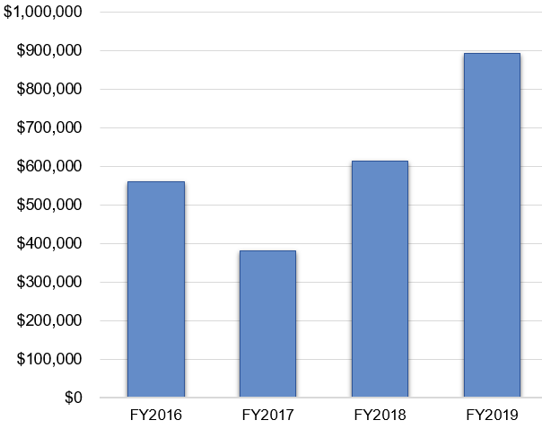

Academic Unit Comparison
Academic Unit | FY2016 | FY2017 | FY2018 | FY2019
College of Arts and Sciences | 12,000 | 50,760 | 133,373 | 120,088
School of Education and Human Services | 0 | 0 | 32,500 | 118,847
School of Health Sciences | 8,500 | 0 | 0 | 0
School of Medicine | 0 | 9,984 | 0 | 0
Other | 538,940 | 319,025 | 447,931 | 655,482
Total | $559,440 | $379,769 | $613,804 | $894,417

FY 2019 Other Sponsored Activities Awards by Source
Source | Amount | Amount Percentage | Number of Awards | Number Percentage
Federal | 10,000 | 8.1% | 1 | 5.6%
State/Local | 772,829 | 86.4% | 14 | 77.8%
Public/Nonprofit | 111,588 | 12.5% | 3 | 16.6%
Total | $894,417 | 100.0% | 18 | 100.0%

Other Sponsored Activities by Department
Fiscal Years 2016 – 2019
College of Arts and Sciences | FY2016 | FY2017 | FY2018 | FY2019
Art and Art History | 12,000 | 18,000 | 0 | 10,000
Psychology | 0 | 32,760 | 0 | 0
Sociology and Anthropology | 0 | 0 | 133,373 | 110,088
CAS Total | $12,000 | $50,760 | $133,373 | $120,088

School of Education and Human Services | FY2016 | FY2017 | FY2018 | FY2019
Human Development and Child Studies | 0 | 0 | 32,500 | 117,347
Organization Leadership | 0 | 0 | 0 | 1,500
SEHS Total | $0 | $0 | $32,500 | $118,847

School of Health Sciences | FY2016 | FY2017 | FY2018 | FY2019
SHS Total | $8,500 | $0 | $0 | $0

School of Medicine | FY2016 | FY2017 | FY2018 | FY2019
SOM Total | $0 | $9,984 | $0 | $0

Other | FY2016 | FY2017 | FY2018 | FY2019
Campus Recreation | 0 | 20,000 | 0 | 0
Center for Student Activities | 10,550 | 0 | 0 | 0
Diversity, Equity and Inclusion | 0 | 0 | 0 | 16,355
Graduate Study and Lifelong Learning | 0 | 0 | 0 | 104,772
Library | 0 | 0 | 6,410 | 0
Office of the Senior Associate Provost | 0 | 100,000 | 0 | 0
Macomb-OU Incubator | 281,590 | 55,000 | 145,946 | 197,995
OU Incubator | 221,800 | 119,025 | 45,950 | 34,000
Pre-College Programs | 0 | 0 | 0 | 140,000
Research Office | 25,000 | 25,000 | 249,625 | 162,360
Other Total | $538,940 | $319,025 | $447,931 | $655,482

Oakland University Total | FY2016 | FY2017 | FY2018 | FY2019
Grand Total Other Sponsored Activities | $559,440 | $379,769 | $613,804 | $894,417
Grand Total Funding | $10,878,037 | $11,944,872 | $9,598,612 | $9,121,729

Other Sponsored Activities Awards by Unit, Department and Principal Investigator
College of Arts and Sciences
Art and Art History
Goody, Stephen; FY2019 Project Support; Michigan Council for Arts and Cultural Affairs, $10,000
Sociology and Anthropology
Reger, Joanne; Editorship of Gender and Society; Sociologists for Women in Society, $66,450
Reger, Joanne; Editorship of Gender and Society; Sociologists for Women in Society, $43,638
School of Education and Human Services
Human Development and Child Studies
Korneder, Jessica; MISD School-Based ABA Services; Macomb Intermediate School District, $67,347
Korneder, Jessica; University Autism Program; Michigan Department of Health and Human Services, $50,000
Organizational Leadership
Jourian, Trent; Activating Trans Masculine College Students' Reflections on Campus Experiences, Masculinity, and Community-Building through Long-Term Online Focus Groups; National Student Affairs Administrators in Higher Education, $1,500
Other
Diversity, Equity and Inclusion
Martinez, Chad; Raising Awareness of Sexual Assault and Campus Resources; Michigan State Police $16,355
Graduate Study and Lifelong Learning
Rammel, Claire; King-Chavez-Parks Program for Future Faculty Fellowships; State of Michigan, $104,772
Macomb-OU Incubator
Herriman, Lawrence; Business Accelerator Fund-Client Engagement, Security Vitals; Grand Valley State University/MEDC, $10,000
Herriman, Lawrence; Business Accelerator Fund-Client Engagement-Union and Company; Grand Valley State University/MEDC, $10,000
Herriman, Lawrence; Accelerator Development Funds-Discretionary; Grand Valley State University/MEDC, $30,000
Herriman, Lawrence; MSF 2015 Business Incubators; Michigan Economic Development Corporation, $147,995
OU Incubator
Kent, Stephen; Business Accelerator Fund-Client Engagement, Innovative Billboards, LLC; Grand Valley State University/MEDC, $4,000
Kent, Stephen; Accelerator Development Funds-Discretionary; Grand Valley State University/MEDC, $30,000
Pre-College Programs
McCloud, Reginald; College Day; State of Michigan, $140,000
Research Office
Stone, David; T3N 3.0; University of Michigan/MEDC, $50,000
Stone, David; Business Incubator Programs; Michigan Economic Development Corporation, $74,860
Stone, David; T3N 3.0; University of Michigan/MEDC, $37,500
Number of Proposals Submitted, FY 2016-2019
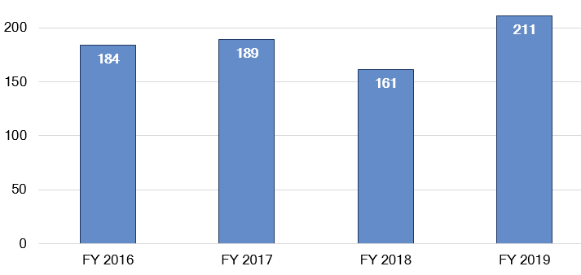

Number of Proposals Submitted by Academic Unit, FY 2016-2019
Academic Unit | FY2016 | FY2017 | FY2018 | FY2019 | Grand Total
CAS | 86 | 98 | 88 | 99 | 371
ERI | 5 | 0 | 1 | 3 | 9
SBA | 3 | 2 | 0 | 2 | 7
SECS | 50 | 45 | 45 | 52 | 192
SEHS | 6 | 5 | 9 | 13 | 33
SHS | 11 | 14 | 8 | 20 | 53
SOM | 4 | 6 | 3 | 6 | 19
SON | 4 | 5 | 3 | 8 | 20
Other | 15 | 14 | 4 | 8 | 41
Grand Total | 184 | 189 | 161 | 211 | 745

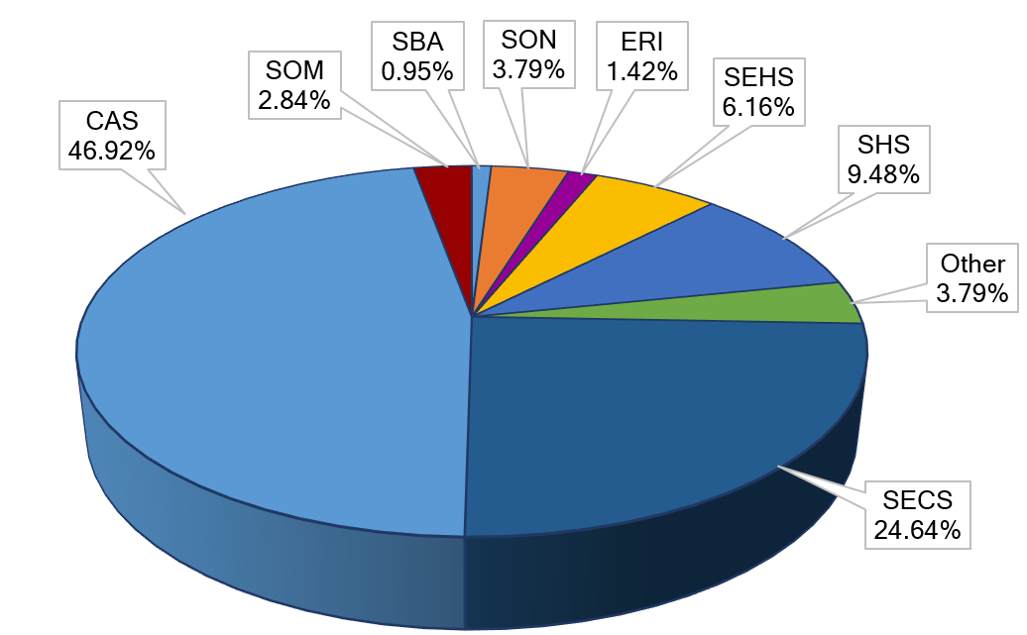
FY 2019 Proposals Submitted by Academic Unit

N = 211

FY 2019 Proposals Submitted by Academic Unit, continued
College of Arts and Sciences | FY2018 | FY2019
Art and Art History | 1 | 2
Biological Sciences | 32 | 28
Chemistry | 28 | 38
Mathematics and Statistics | 3 | 2
Philosophy | 0 | 2
Physics | 19 | 24
Political Science (Pre-Law) | 1 | 1
Psychology | 2 | 2
Sociology and Anthropology | 2 | 0
CAS Total | 88 | 99

Eye Research Institute | FY2018 | FY2019
ERI Total | 1 | 3

School of Business Administration |  | FY2018 |  | FY2019
Management and Marketing | 0 |  | 2
SBA Total | 0 |  | 2

School of Engineering and Computer Science |  | FY2018 |  | FY2019
Computer Science and Engineering | 11 |  | 22
Electrical and Computer Engineering | 9 |  | 14
Industrial and Systems Engineering | 6 |  | 6
Mechanical Engineering | 19 |  | 10
SECS Total | 45 |  | 52

School of Education and Human Services |  | FY2018 |  | FY2019
Human Development and Child Studies | 4 |  | 4
Reading and Language Arts | 2 |  | 3
Teacher Development and Educational Studies | 2 |  | 2
Organizational Leadership | 1 |  | 4
SBA Total | 9 |  | 13

School of Health Science | FY2018 | FY2019
Interdisciplinary Health Science | 7 | 13
Human Movement Science | 1 | 4
Public and Environmental Wellness | 0 | 3
SHS Total | 8 | 20

School of Medicine | FY2018 | FY2019
SOM Total | 3 | 6

School of Nursing | FY2018 | FY2019
SON Total | 3 | 8

Other |  | FY2018 |  | FY2019
Academic Affairs | 0 |  | 1
Center for Multicultural Initiatives | 1 |  | 1
Diversity, Equity and Inclusion | 0 |  | 1
Library | 0 |  | 1
Meadow Brook Hall | 1 |  | 0
Plant Engineering | 0 |  | 1
Pre-College Programs | 1 |  | 2
Research Office | 1 |  | 1
Other Total | 4 |  | 8
Percentage and Amounts Requested by Academic Unit
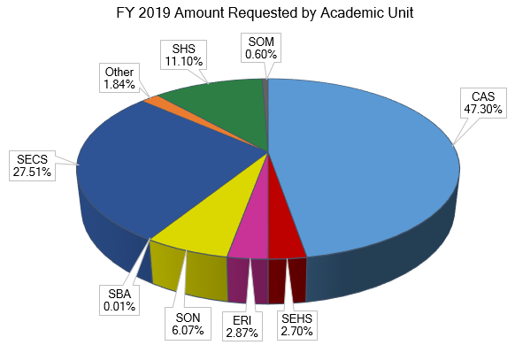

N = $70,986,156

Amount Requested by Academic Unit, FY 2016-2019
Academic Unit | FY2016 | FY2017 | FY2018 | FY2019 | Grand Total
CAS | 27,615,238 | 46,189,248 | 32,526,732 | 33,575,125 | 139,906,343
ERI | 4,196,703 | 0 | 1,875,000 | 2,034,157 | 8,105,860
SBA | 337,614 | 566,257 | 0 | 8,962 | 912,833
SECS | 9,061,603 | 8,088,067 | 8,035,043 | 19,530,994 | 44,715,707
SEHS | 7,100,114 | 2,379,048 | 2,991,058 | 1,917,226 | 14,387,446
SHS | 872,261 | 1,043,560 | 739,423 | 7,881,792 | 10,537,036
SOM | 483,014 | 116,632 | 10,250 | 424,193 | 1,034,089
SON | 1,966,846 | 1,259,052 | 1,335,108 | 4,309,136 | 8,870,142
Other | 1,415,197 | 4,984,757 | 982,570 | 1,304,571 | 8,687,095
Grand Total | $53,048,590 | $64,626,621 | $48,495,184 | $70,986,156 | $237,156,551

Proposal Funding Requested by Academic Unit
College of Arts and Sciences | FY2018 | FY2019
Art and Art History | 20,000 | 25,000
Biological Sciences | 14,278,109 | 17,915,867
Chemistry | 12,339,927 | 9,112,615
Mathematics and Statistics | 266,659 | 319,122
Philosophy | 0 | 338,375
Physics | 5,176,550 | 5,136,956
Political Science | 22,717 | 17,999
Psychology | 389,779 | 709,191
Sociology and Anthropology | 32,991 | 0
CAS Total | $32,526,732 | $33,575,125

Proposal Funding Requested by Academic Unit, continued
Eye Research Institute | FY2018 | FY2019
ERI Total | $1,875,000 | $2,034,157

School of Business Administration | FY2018 | FY2019
Management and Marketing | 0 | 8,962
SBA Total | $0 | $8,962

School of Engineering & Computer Science | FY2018 | FY2019
Computer Science and Engineering | 2,118,370 | 9,876,590
Electrical and Computer Engineering | 1,576,381 | 3,672,108
Industrial and Systems Engineering | 1,111,279 | 1,830,501
Mechanical Engineering | 3,229,013 | 4,151,795
SECS Total | $8,035,043 | $19,530,994

School of Education and Human Services | FY2018 | FY2019
Human Development and Child Studies | 1,604,563 | 1,539,514
Organizational Leadership | 264,000 | 67,630
Teacher Development and Educational Studies | 121,905 | 94,926
Reading and Language Arts | 1,000,590 | 215,156
SEHS Total | $2,991,058 | $1,917,226

School of Health Sciences | FY2018 | FY2019
Human Movement Science | 0 | 408,986
Interdisciplinary Health Sciences | 739,423 | 6,309,273
Public and Environmental Wellness | 0 | 1,163,533
SHS Total | $739,423 | $7,881,792

School of Medicine | FY2018 | FY2019
SOM Total | $10,250 | $424,193

School of Nursing | FY2018 | FY2019
SON Total | $1,335,108 | $4,309,136

Other | FY2018 | FY2019
Academic Affairs | 0 | 32,612
Center for Multicultural Initiatives | 645,390 | 100,483
Diversity, Equity and Inclusion | 0 | 31,655
Facilities Management | 0 | 730,125
Library | 0 | 9,943
Meadow Brook Hall | 262,000 | 0
Pre-College Programs | 62,680 | 305,636
Research Office | 12,500 | 94,117
Other Total | $982,570 | $1,304,571

FY 2018 Proposal Funding Requested by Purpose

FY2019 ● Amount Requested by Purpose
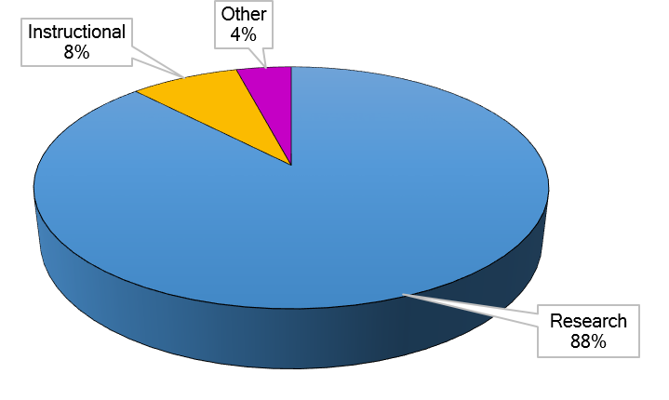
N = $70,986,156

College of Arts and Sciences | Research | Instructional | Other Sponsored Activities
Art and Art History | 0 | 0 | 25,000
Biological Sciences | 17,915,867 | 0 | 0
Chemistry | 9,112,615 | 0 | 0
Mathematics and Statistics | 319,122 | 0 | 0
Philosophy | 338,375 | 0 | 0
Physics | 5,136,956 | 0 | 0
Political Science | 0 | 0 | 17,999
Psychology | 709,191 | 0 | 0
CAS Total | $33,532,126 | $0 | $42,999

Eye Research Institute | Research | Instructional | Other Sponsored Activities
ERI Total | $2,034,157 | $0 | $0

School of Business Administration | Research | Instructional | Other Sponsored Activities
Management and Marketing | 2,500 | 6,462 | 0
SEHS Total | $2,500 | $6,462 | $0

FY 2019 Proposal Funding Requested by Purpose, continued
School of Engineering and Computer Science | Research | Instructional | Other Sponsored Activities
Computer Science and Engineering | 9,228,902 | 647,688 | 0
Electrical and Computer Engineering | 3,240,696 | 0 | 431,412
Industrial and Systems Engineering | 1,830,501 | 0 | 0
Mechanical Engineering | 3,162,272 | 989,523 | 0
SECS Total | $17,462,371 | $1,637,211 | $431,412

School of Education and Human Services | Research | Instructional | Other Sponsored Activities
Human Development and Child Studies | 1,422,167 | 0 | 117,347
Organizational Leadership | 67,630 | 0 | 0
Reading and Language Arts | 215,156 | 0 | 0
Teacher Development and Educational Studies | 94,926 | 0 | 0
SEHS Total | $1,799,879 | $0 | $117,347

School of Health Sciences | Research | Instructional | Other Sponsored Activities
Human Movement Science | 388,985 | 0 | 20,001
Interdisciplinary Health Sciences | 5,266,042 | 0 | 1,043,231
Public and Environmental Wellness | 1,163,533 | 0 | 0
SEHS Total | $6,818,560 | $0 | $1,063,232

School of Medicine | Research | Instructional | Other Sponsored Activities
SOM Total | $424,193 | $0 | $0

School of Nursing | Research | Instructional | Other Sponsored Activities
SON Total | $161,897 | $4,135,118 | $12,121

Other | Research | Instructional | Other Sponsored Activities
Academic Affairs | 32,612 | 0 | 0
Center for Multicultural Initiatives | 0 | 0 | 100,483
Diversity, Equity and Inclusion | 0 | 0 | 31,655
Facilities Management | 0 | 0 | 730,125
Library | 9,943 | 0 | 0
Pre-College Programs | 0 | 0 | 305,636
Research Office | 0 | 0 | 94,117
Other Total | $42,555 | $0 | $1,262,016

Oakland University Total | Research | Instructional | Other Sponsored Activities
Grand Total | $62,278,238 | $5,778,791 | $2,929,127
FY 2019 Proposal Funding Requested by Source
FY2019 ● Amount Requested by Source
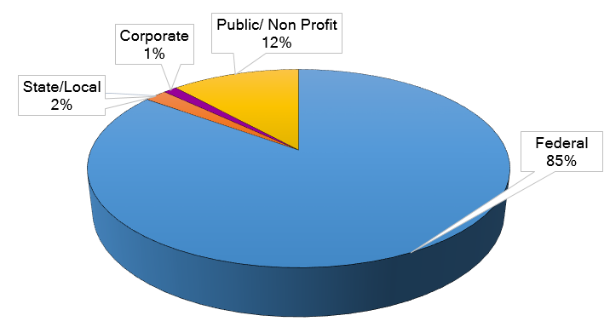
N = $70,986,156

College of Arts & Sciences | Federal | State/Local | Corporate | Public/  Nonprofit
Art and Art History | 25,000 | 0 | 0 | 0
Biological Sciences | 16,289,209 | 0 | 0 | 1,626,658
Chemistry | 6,734,340 | 11,501 | 0 | 2,366,774
Mathematics and Statistics | 277,122 | 0 | 0 | 42,000
Philosophy | 330,078 | 0 | 0 | 8,297
Physics | 4,370,688 | 0 | 0 | 766,268
Political Science | 0 | 17,999 | 0 | 0
Psychology | 709,191 | 0 | 0 | 0
CAS Total | $28,735,628 | $29,500 | $0 | $4,809,997

Eye Research Institute | Federal | State/Local | Corporate | Public/  Nonprofit
ERI Total | $2,009,997 | $0 | $0 | $24,160

School of Business Administration | Federal | State/Local | Corporate | Public/  Nonprofit
Management and Marketing | $0 | $0 | $8,962 | $0
SBA Total | $0 | $0 | $8,962 | $0

FY 2019 Proposal Funding Requested by Source, continued
School of Engineering and Computer Science | Federal | State/Local | Corporate | Public/  Nonprofit
Computer Science and Engineering | 8,717,634 | 88,735 | 0 | 1,070,220
Electrical and Computer Engineering | 2,754,850 | 0 | 663,450 | 253,808
Industrial and Systems Engineering | 1,680,501 | 0 | 150,000 | 0
Mechanical Engineering | 4,111,796 | 0 | 40,000 | 0
SECS Total | $17,264,781 | $88,735 | $853,450 | $1,324,028

School of Education and Human Services | Federal | State/Local | Corporate | Public/  Nonprofit
Human Development and Child Studies | 1,399,999 | 139,515 | 0 | 0
Organizational Leadership | 14,000 | 0 | 0 | 53,630
Reading and Language Arts | 202,757 | 0 | 0 | 12,399
Teacher Development and Educ Studies | 0 | 0 | 0 | 94,926
SEHS Total | $1,616,756 | $139,515 | $0 | $160,955

School of Health Sciences | Federal | State/Local | Corporate | Public/  Nonprofit
Human Movement Science | 0 | 0 | 20,001 | 388,985
Interdisciplinary Health Sciences | 4,837,341 | 7,000 | 0 | 1,464,932
Public and Environmental Wellness | 1,163,533 | 0 | 0 | 0
SHS Total | $6,000,874 | $7,000 | $20,001 | $1,853,917

School of Medicine | Federal | State/Local | Corporate | Public/  Nonprofit
SOM Total | $414,693 | $0 | $0 | $9,500

School of Nursing | Federal | State/Local | Corporate | Public/  Nonprofit
SON Total | $4,144,992 | $12,121 | $0 | $152,023

Other | Federal | State/Local | Corporate | Public/  Nonprofit
Academic Affairs | 32,612 | 0 | 0 | 0
Center for Multicultural Initiatives | 0 | 100,483 | 0 | 0
Diversity, Equity and Inclusion | 0 | 31,655 | 0 | 0
Facilities Management | 0 | 730,125 | 0 | 0
Library | 9,943 |  | 0 | 0
Pre-College Programs | 0 | 305,636 | 0 | 0
Research Office | 94,117 | 0 | 0 | 0
Other Total | $136,672 | $1,167,899 | $0 | $0

Oakland University Total | Federal | State/Local | Corporate | Public/  Nonprofit
Grand Total | $60,324,393 | $1,444,770 | $882,413 | $8,334,580

Research, Innovation, and Engagement Town Hall - 2018 Winners

Frank Giblin Lifetime Achievement Award
Dr. Yang Xia
Department of Physics, CAS

Researcher of the Year
Dr. Randal J. Westrick
Department of Biological Sciences, CAS

Most Research Active
Dr. Zissimos P. Mourelatos
Department of Mechanical Engineering, SECS

Most Active Grant Seeker
Dr. Xiangqun Zeng
Department of Chemistry, CAS

Most Active Grant Seeker (Honorable Mention)
Dr. Colin Wu
Department of Chemistry, CAS

Outstanding Research Department
Biological Sciences, CAS

Outstanding Junior Investigator
Dr. Laurel Dolin Stevenson
Department of Interdisciplinary Health Sciences, SHS

PI Academy for Research and Engagement, Class of 2019
Sharon Berry, Philosophy, CAS
Elise Brown, Public and Environmental Wellness, SHS
Jingshu Chen, Computer Science and Engineering, SECS
Ilias Cholis, Physics, CAS
Felicia Chong, Writing and Rhetoric, CAS
Christopher Cooley, Mechanical Engineering, SECS
Erin Dwyer, History, CAS
Jickssa Gemechu, Biomedical Sciences, OUWB
Michelle Hammond, Management and Marketing, SBA
Mary Jamieson, Biological Sciences, CAS
T.J. Jourian, Organizational Leadership, SEHS
Brendan Kredell, Cinema Studies, CAS
Anyi Liu, Computer Science and Engineering, SECS
Matthew May, Sociology, CAS
Hua Ming, Computer Science and Engineering, SECS
Atiqul Mollah, Computer Science and Engineering, SECS
Kristen Munyan, Nursing, SON
Sang Hoon Rhee, Biological Sciences, CAS
Ed Rohn, Interdisciplinary Health Sciences, SHS
Kate Rougeau, Public and Environmental Wellness, SHS
Julian Rrushi, Computer Science and Engineering, SECS
Amartya Sen, Computer Science and Engineering, SECS
Missie Smith, Industrial and Systems Engineering, SECS
Ahmad Sobhani, Decision and Information Sciences, SBA
Sam Srauy, Communication and Journalism, CAS
Greg Thrasher, Management and Marketing, SBA
Christopher Wilson, Human Movement Science, SHS
Douglas Zytko, Computer Science and Engineering, SECS

Research Office
Wilson Hall, Room 529 | 371 Wilson Boulevard, Rochester, MI 48309-4486
(248) 370-2762 | oakland.edu/research

